12. Design and implement the 8:1 MUX using gates /ICs

8:1 MULTIPLEXER
AIM: To verify the truth table of Multiplexer.

Theory:
The TTL/MSI SN54/74LS151 is a high speed 8-input Digital Multiplexer. It provides, in one
package, the ability to select one bit of data from up to eight sources. The LS151 can be used as universal function generator to generate any logic function of 4 variables. Both assertion and negation outputs are provided.

• Schottky Process for high speed
• Multifunction capability
• On-chip select logic decoding.
• Fully buffered complementary outputs
• Input clam diodes limit high speed termination effects.

Functional description:
The LS151 is a logical implementation of a single pole, 8-position switch with the switch
position controlled by the state of three select inputs, s0, s1, s2. Both assertion and negation
outputs are provided. The enable input (E) is active LOW. When it is not activated, the negation
output is HIGH and assertion output is LOW regardless of all other inputs.
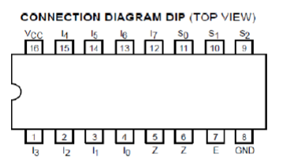
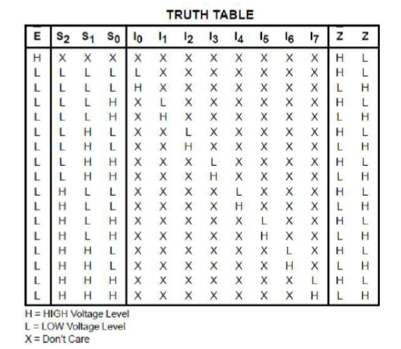
PROCEDURE:
1. Connect Inputs S2, S1, S0, I0, I1, I2, I3, I4, I5, I6, I7 and Enable (E) to Logic Input Sockets.
2. Connect Output terminal Z &̅ Z to Logic Output Sockets.
3. Verify output with given Truth Table.

CONCLUSION: Hence verified the truth table of Multiplexer.

13. Write 8085 Program 8-bit addition

MVI C, 00H : Initialize Register C to 00H to store Carry
LDA 2500H : Load the 1st number from memory location 2500H into Accumulator
MOV B, A : Move the 1st number from Accumulator to Register B
LDA 2501H : Load the 2nd number from memory location 2501H into Accumulator
ADD B : Add contents of Register B to the Accumulator (A = A + B)
JNC SAVE : If Carry flag = 0 (No Carry), jump to SAVE
INR C : If Carry flag = 1, increment Register C by 1

SAVE:
STA 2502H : Store the lower 8-bit sum from Accumulator to 2502H
MOV A, C : Move the Carry value from Register C to Accumulator
STA 2503H : Store the Carry value from Accumulator to 2503H
HLT : Halt/Terminate the program execution

14. Write 8085 Program 8-bit Subtraction

ORG 2000H : Starting address of the program
MVI C, 00H : Initialize Register C to 00H to track borrow status
LHLD 2500H : Load HL register pair: L gets data from 2500H, H gets data from 2501H
MOV A, H : Move the first number (from H) into the Accumulator
SUB L : Subtract the second number (in L) from the Accumulator (A = A - L)

JNC STORE : If Carry flag (Borrow) is NOT set (JNC), jump to STORE
INR C : If Carry is set, increment Register C to 01H (indicates a borrow)
CMA : Find 1's complement of the Accumulator to calculate 2's complement magnitude
ADI 01H : Add 01H to get the 2's complement representation of the negative result

STORE:
STA 2502H : Store the subtraction result from Accumulator into memory location 2502H
MOV A, C : Move the borrow status from Register C into the Accumulator
STA 2503H : Store the borrow status into memory location 2503H
HLT : Halt the program execution

